Lyn Innes

Writing the Story of the Last Nawab of Bengal's English Family.

I was about five years old and we had just moved to a new house on our Australian farm, when I discovered in the bottom of a box my mother was unpacking a yellowed newspaper page with a photograph of an Indian prince. The man in the photograph wore a fez with a feather, a long embroidered silk jacket, and a sword. My mother read the caption beneath the photograph to me: 'The Nawabzada Nusrat Ali Mirza of Murshidabad who attended court on June 5th. The Prince is the son of the late Nawab Nazim of Bengal, Bihar, and Orissa and is the Uncle of the present Nawab of Murshidabad.'
See Figure 1: The Nawabzada Nusrat Ali Mirza of Murshidabad
The words meant very little to me but my mother explained that this man was her father, and it was he who had painted the small rural landscape she had hung on the living room wall. The landscape had brown cows and pine trees in a meadow. The scene did not look either Australian or Indian; I supposed it was English.
My mother's family had emigrated to Australia from England in 1927 when she was fourteen years old. At that time the White Australia Policy was in force, barring all 'Asiatics' from residing in that country. My grandfather changed his name to Norman Alan Mostyn, pointed out that his mother was English, and was permitted to live in Australia on condition that he did not admit to being Indian or, as the immigration authority termed it, 'half-caste'. We children were told it was best not to talk about our grandfather (who had died in 1941). Nevertheless we soon learned when we started going to school that he was known locally as 'the black prince,' an epithet always said with a sneer.
And so the details of my mother's ancestry remained for many years unspoken and undiscussed. Then when I was a teenager, we began to receive letters and little gifts from my great-Aunt Vaheedoonissa, who lived in Bengal. She sent silk scarves and sandalwood perfume from Murshidabad, and her letters commented on the political turmoil in Pakistan which resulted in a military coup against President Iskander Mirza, my mother's cousin. Now I wanted to know more, and began to question my mother, although she was still reluctant to say much. What she did tell me seemed inconsistent or vague.
It was only after I retired from my academic career as a specialist in postcolonial literatures that I could give my time and attention to tracing the story of my grandparents and great grandparents, and the route that had led them from Murshidabad, in north west Bengal, via England, Jamaica, Paris and Wales, to the Capertee Valley in north west New South Wales, near the farm where I grew up. My research involved unravelling and reconstructing much of the family narrative I had heard earlier.
See Maps of Bengal, and Capertee Valley, New South Wales, Figures 2 and 3
The story passed down to me was that my great grandmother was a governess who had won the heart of an Indian Nawab. I imagined a scenario resembling 'The King and I', featuring ancestors like Yul Brynner and Debbie Reynolds. However, when many years later, a genealogist revealed that my great grandmother was in fact a hotel maid, her story became even more intriguing: How did they meet? And what could it have been like for her to be married to a Muslim nobleman? Why was he in London and why did he stay there for ten years?

The Nawab's Marriage to Sarah Vennell
I found that in 1869 the Nawab Nizam of Bengal, Bihar and Orissa left his Indian wives and many mistresses in Bengal and travelled to London to petition the British Government for the repayment of money and restitution of rights promised his family by the East India Company and the British Government. His visit was reported by numerous newspapers, and he was received by Queen Victoria and many British grandees.

See Figure 4: "Be Just and Fear Not." Cartoon from Tomahawk showing the Nawab and his three sons petitioning Queen Victoria
.
The Census for 1971 shows that the Nawab stayed in the luxurious Alexandra Hotel with his two sons and a retinue of twelve servants, including a scripture reader, a musician, a cook, and a eunuch. There he met and married Sarah Vennell, a seventeen year old chambermaid working in the hotel. They lived together in London for ten years, and had six children, the youngest of whom was to become my grandfather.
At first I thought I would try to write a novel about this couple, or about their son, my grandfather, but to do so I felt I needed a much deeper understanding of their histories, their social and political worlds, their beliefs. And so began many months of investigation which gradually led to a fascination with all four characters involved, a fascination which seemed best conveyed by biographical rather than fictional writing, a book which would link those individual histories to the changing history of the British Empire.
Historical and Cultural Contexts
One difficulty I had was deciding where to begin: should it be with the Battle of Plassey and Clive of India's conquest on behalf of the East India Company, a conquest which led to the British occupation of the whole sub-continent of India, and the installation of Mir Jafir, the Nawab's ancestor, as puppet ruler? Or should I start with the Nawab's succession to the throne at the age of eight in 1838? And then there was the story of Sarah and her family, her ancestors displaced from rural Kent during the 1820s: how would that be woven into the tapestry? Another beginning might be the discovery of my own family connection with the Nawab and the unraveling of often misleading oral anecdotes and fragments of information about our ancestors? Each of those possible beginnings implied further choices involving audience, point of view, and the kind of book I would try to write. I continue to wrestle with these problems.
Another difficulty, but also an interesting challenge, was the departure from the kind of academic writing I had done all my life. In such writing the task was usually clear-- an essay or book on a specific writer or literary area, for a specific audience and a specific publisher. Now I found myself in new territory--or rather several new territories-- with a series of possible trails leading to no clear destination. And with each new trail, new discoveries and new possible directions would suddenly open up. What I was also discovering, I suppose, was the nature of biographical writing, where the understanding of a particular person's life involves also an understanding of the world he or she inhabits-- the personal, political, cultural forces which impacted on that life. This was, and continues to be, both daunting and exciting.
For me perhaps the greatest pleasure in researching this story has been the exploration of the worlds the Nawab and his English wife and children inhabited. That exploration has involved learning Urdu, the main language the Nawab spoke, visiting Bengal, trying to understand the specific differences between Shia and Sunni Muslim beliefs and ceremonies, investigating and listening to North Indian court music, reading the memos and letters of British officials in Bengal and London, researching schools and syllabuses in London in the 1850s, finding out about nineteenth century shop-keeping and guilds in London, and looking into the growth of luxury hotels in London and attitudes towards servants there. In pursuit of my grandparents, I have been investigating Jamaica in the first decade of the 20th century, Paris and the art scene between 1910 and 1914, village life in northern Wales in the 1920s, the white Australian immigration policy and rural life in Australia in the 1930s.
This essay dwells on the earlier parts of my research and writing, investigating the relationship between the Nawab and the British, and what it was like for one particular person to be ruled by the British, a study of what has been called in another context 'the intimate Empire'. My research has involved reading through hundreds of letters and memos kept by the India office, visiting Murshidabad, which was British once the capital of East India, and searching British, French, and Indian newspapers for the relevant period.

The Nawab's British Custodians
What astonished me when reading these documents was how closely the British kept watch over the young Nawab after he succeeded to the throne at the age of eight in December 1838. At that point he received a letter from the Earl of Auckland, who was Governor General of India congratulating the young Nawab on his succession to 'the throne of his ancestors' and promising that 'the dignity and honour of the illustrious house you now represent will ever be an object of care and solicitude to this Government.' That solicitude was to become very oppressive, and indeed claustrophobic. At times it seems almost farcical.
Lord Auckland requested that the British Agent in Murshidabad keep a diary 'showing how His Highness the Nazim passes his time', recording his progress in his studies, and noting 'any particular traits of his general disposition and character' which might strike him as worthy of notice. The British agent appointed an English tutor, Francis Seddon, who was Professor of Oriental Languages at Kings College, London. The Agent also took it upon himself to examine the young Nawab every Monday morning in both English and Persian. The eight-year-old boy was required to attend classes in English from 7 am to 1 pm, and then study Persian and Arabic till 5 pm. Before 7 am he was expected to go riding with his English tutor, and then again after 5pm.
The long and laboriously written reports from Seddon and the British Agent about the young Nawab's progress are all held in the India Office files. They reveal varying degrees of conflict between the Agent, the tutors, and--above all-- the child, who at first strongly resisted their insistence on his learning English. "My father did not learn English, my grandfather did not speak it, none of my ancestors spoke it, so why should I learn English?" he asked. Such questioning displeased the British Agent, who in an 1839 report characterised the boy as "too much aware of his status; proud, unsteady, and volatile."

Although the young Nawab at first made slow and reluctant progress in his ability to speak and write English, he quickly became proficient at writing Persian, and clearly enjoyed doing so. An early tutorial report comments that he would frequently stay on after his writing lesson "and take up the reed and write his Persian copies, his little fingers sometimes forming strokes that would do little discredit to the most practised penman." Was this dedication to Persian perhaps the child's way of paying tribute to his father and a heritage that did not belong to the British?
Nevertheless his English education continued. At twelve years of age he spoke English so well that his tutor noted that if one heard him speaking in another room you would not know he was Indian. He was now reading Byron, and Tennyson, and was able to recite at length "The Lady of Shalott." – He was also given Thomas Moore's "Llala Rookh,"--a significant choice since it portrays Muslim rulers in India as tyrannical and oppressive. It is interesting to note that his education involved reading contemporary British literature at a time when English public schools would have confined their curriculum to Latin and Greek literature.
Leafing through the boxes and boxes of files containing page after page of formal and informal memos and letters, all carefully copied in fading brown ink onto foolscap paper, I found lists of the books bought for the Nawab's studies, accounts for the purchase of cricket bats and horses, marginal notes querying or approving such purchases, and then a flurry of increasingly anxious memos concerning the boy's sexual development. With the approval of the Governor General, the British Agent decides that the twelve year old boy must now be removed from his mother's palace and the 'harmful influence' of the women's quarters. By the time he is fourteen they are trying to arrange a marriage for him, and one year later he is married to a distant cousin.
The India Office Boxes also contain detailed quarterly accounts showing the stipends and incidental expenses paid to servants, courtiers, relatives, wives and concubines. As so many have similar names, it is not always easy to discover the status of each person listed, but the British civil servants take care that stipends and status are ranked in the proper order. The Nawab's English tutor is allocated 1200 rupees a month; his Persian tutor, 400 rupees a month. There is a large stipend for the Nawab's mother, a little less for his senior or first wife, and much less for a mutah or temporary wife.
These papers gave me glimpses of my great-grandfather as a boy, sometimes petulant, sometimes disconsolate, torn between the demands of his British guardians and watchdogs and his adherence to his identity as a Muslim and a member of a ruling Indian dynasty. But the reports and memos were almost all written by the British Agents and tutors, with their own cultural and political agenda, often dismissive of Islam and Indians. As the Nawab grew older his own letters and memos were included, but they were very formal, and couched in terms designed to acknowledge the British point of view. How could I find the person, the thoughts and feelings, disguised by these formal phrases and acknowledgements and overlooked or misinterpreted by his British mentors?
Occasionally a less official portrayal appears in the letters and memoirs of wives of British Agents and officials. During the 1850s, and at the time of the rebellions referred to by the British as 'the Indian Mutiny', the Nawab, now in his twenties, had a particularly tempestuous relationship with a British Agent named Colin MacKenzie. Mackenzie's letters refer to the people of Murshidabad as 'the scum of the earth'. He accuses the Nawab of disgracing his family and failing to acknowledge that he would be bereft without the British (even though the Nawab gave substantial support to the British during the rebellions). MacKenzie's wife Helen presents a friendlier aspect, however: she tells how the Nawab entertained them with musical evenings (which the MacKenzies did not appreciate), and took the couple and other officials on safaris. Once during a ten day safari he did not go hunting because it was a Friday and he was a devout Muslim; instead he stayed with her in her tent and taught her to play chess. She described the Nawab as amiable and charming.

Visiting the Palace in Murshidabad
Reading official and unofficial letters and memoirs helped create a sense of the world the Nawab contended with, but I needed a clearer sense of the world he inhabited. In 2008 I travelled to Kolkata and then 100 miles north. to Murshidabad, the site of the Nawab's palace. Once the capital of East India, with a population of over a quarter of a million diverse Indian and European peoples, Murshidabad was described by Robert Clive in 1750 as wealthier and more beautiful than London. Now it is a much smaller and poorer town reached by a bumpy dirt road. Nevertheless, evidence of its past grandeur and diversity remains, with ancient mosques, Sikh and Jain temples, bazaars selling the silks and carved miniatures which are a specialty of the area.
The palace is now a state museum and heritage site, visited by hundreds of Indian schoolchildren and adults each day. It is grand rather than beautiful, built in classical European style to impress, and from the outside reminiscent of London's National Gallery. Opposite is the Imbara, the pilgrim's hostel built by the Nawab in 1848, an elegant white building which evokes the Muslim culture my great-grandfather and his sons espoused. Together these two buildings powerfully embodied the secular, political and religious worlds that sustained the Nawab.

See figures 5 and 6, The Hazarduari Palace and the Imbara

Inside the Hazarduari Palace those worlds co-existed. There was a portrait gallery showing all the Nawab's ancestors, back to Mir Jafir, and three portraits of the Nawab himself, two as a very elegant young man, and one made when he was in his late forties. In the library was a splendid Koran that had once belonged to the Caliph of Baghdad, but there were also all of Walter Scott's novels, Shakespeare's plays, and the writings of Aristotle. The art gallery featured not traditional Indian works but a fine collection of early nineteenth century English landscapes. There were beautifully carved ivory chess sets and nearby a huge stuffed crocodile, open-jawed. Also on display was a plate that changed colour if the food placed on it was poisoned, and a mirror that showed not the person facing it but the people behind him. Such artifacts betrayed the paranoia that surrounded the Nawabs who held nominal power and actual wealth.
See figures 7 and 8: The Nawab Nazim of Bengal, Bihar and Orissa, aged 18 and 40
The India Office records had given a chronology, a series of events and names, a version of a political history in which my great-grandfather was caught up. Now my visit to Murshidabad and the Palace provided the substance I needed to begin writing, the glimpses of attitudes and cultures that encompassed the British but also went beyond them. But the palace and its galleries brought to mind first of all the stories my grandfather had told my mother about his boyhood in India, and I thought of him and his brother as small boys wandering those same galleries, looking at those same artifacts. I decided to write about his experience, and that of his sisters and brothers, suddenly removed from their mother and their house in Bedford Square, and deposited in their Indian grandmother's palace in Murshidabad. The children's thoughts and feelings are imagined or rather, one might say, supposed, but all that they see and experience is anchored in family history, the records in the India Office Files, and my own experience of visiting Murshidabad and the Hazarduari Palace.
The section below begins just after Sarah has discovered that her husband is having an affair with her maid, Julia, and goes to stay with her father. The Nawab then decided to return to India, sending Julia and all the children ahead.
*****
A Passage to India

On November 16, 1880, Sarah’s four children (Mariam, Vaheedoonissa, Syed and Nusrat), together with Julia and her baby daughter Amina, were hustled into carriages which took them to the East India Docks, close to Sarah’s birthplace. They were accompanied by the Nawab’s fourth son, Prince Assad Ali Mirza (Subah Sahib) 1 and the Nawab’s secretary, Valentine Holt. It was two days before Vaheedoonissa’s sixth birthday, and it was the confusing culmination of a confusing year. Just when she had got used to the cosiness of the house in Bedford Square, although she missed her pony and the dogs and the ducks at Pymmes Park, everything had changed. Her mother frequently wept and sometimes shouted at their father; the doctor came frequently; there was much whispering with their uncle George, and the servants gave each other strange looks. Then quite suddenly their mother went away and they were told that Julia, who used to help look after them, was their new mother, and that they should call her Mohamadee. Soon after their mother had disappeared, Hajerah became ill, and the doctor was back looking very serious. He wanted to see all the children and took their temperatures and made them open their mouths very wide while he looked at their tongues and throats. Then they were told Hajerah had died and they did not see her again.
They were going to India with their new mother and baby sister, and Subah Saheb, their older brother. Vaheedoonissa stayed close to nine year old Mariam and her little brothers (now aged five and three). Their father would come later, he told them, and perhaps their real mother would also join them. India was a long way away. It would be hot there, and there would be lots of elephants and monkeys. When they arrived they would be given new clothes and they would see all their other brothers and sisters.

1 Syed Assad Ali Meerza, more familiarly known as Subah Sahib, was Mansur Ali Khan’s fourth son, born in 1855. He was a distinguished artist.

But first they had to get the boat from London. Together with the servants the children stood bewildered on the wharf with hundreds of bodies pushing urgently past them, porters trundling trunks, deafened by people talking and shouting. Looming over them was the huge steamship belching black smoke.
Then Subah Sahib, Mr Holt, and two of the servants came and took their hands, led them up the gangway, onto the deck and down steep stairs to two cabins with bunk beds. Vaheedoonissa and Mariam would share one cabin with one of the servants; Syed and Nusrat were to sleep in the other with another servant. Julia had got fat because she had a baby inside her and needed to have her own big cabin with little Amina and the ayah. During the long six week voyage, those cabins became a familiar refuge.
Five days before they reached Calcutta, the crew and most of the passengers celebrated Christmas. Mariam and Vaheedoonissa could remember the previous Christmas in London with their mother, when the park in Bedford Square was covered with snow and they had to put on their fur coats and boots. Now they were wearing the loose silk pantaloons and tunics bought when the ship stopped at Colombo. They did not have Christmas presents, but Subah Sahib told them it was a special day for eesa, the prophet the English called Jesus, and they should say their prayers and be good.
Then at last they had reached Calcutta. The heat, the noise, the bustle were stupefying. Nusrat and little Amina had to be carried down the gangway to the wharf; Mariam, Vaheedoonissa and Syed followed them guided by the servants. The next day they boarded a much smaller boat on the Hooghly river, and sailed to Murshidabad. They could see the sloping river banks on each side, where sometimes there were women in brightly coloured saris washing clothes and small children splashing in the water. They passed lots of small fishing boats, and as the journey progressed saw big white and black birds with long curved beaks by the water. These, they later learned, were called ibis. And once Subah Sahib pointed out a group of monkeys clambering up a bank towards a group of huge mulberry trees.
Murshidabad was their new home, a home where Vaheedoonissa and Mariam would remain for the rest of their lives. Together with Julia and little Amina they were taken to their grandmother’s palace, where they were introduced to their older sisters and nieces, many of whom were nearer to Mariam and Vaheedoonissa in age. Here the Nawab’s ‘English’ wife and daughters were the focus of much curiosity. Growing up in England with a large household of servants and private tutors, Mariam and Vaheedoonissa had assumed that it was perfectly normal to have an Indian father and an English mother. Now they found that they were pointed at and sometimes pushed aside as ‘angrezi larkhian’ (english girls) and the few Urdu words they had learned from their father and stepbrothers and the servants were inadequate. When they asked questions in English or tried to use their limited Urdu the other children and their mothers just stared or giggled. Occasionally Nawab Hassan visited and brought letters and cards from their mother, but they found it more and more difficult to remember her face and her voice. And soon their other English mother, Julia, left them to stay with their father in Bombay, a long way away on the other side of India.
The boys stayed in their grandmother's palace with their sisters, but they spent most days with their tutors near Mr. Holt and another secretary in apartments in the Hazarduari palace. Years later my grandfather Nusrat had only fragmentary memories of the four years he spent in Murshidabad: the sound of the muezzin in the early morning; long hours sitting cross-legged with the other boys learning and reciting verses from the Koran; the trumpeting of the elephants in the elephant house and watching them bathe and spray themselves in the pool nearby. Sometimes they rode in a tonga drawn by a small pony through the dusty streets of the city, not at all like Bedford Square, out through the big gate past lots of big mulberry trees and muddy fields where men and women stooped to plant or harvest rice.

In one of the palace rooms there was a stuffed crocodile with its gaping mouth and big teeth. Next to it was a mirror which showed not the viewer but anyone standing behind. Here he and Syed spent many hours trying to catch each other out. Once a magician came to his grandmother's palace, and he was allowed to watch through the shutters as the magician made a rope stand still in the air, and then sent a small boy up to its very top. He watched in horror and clutched Vaheedoonissa's arm as the magician threw his knife and the boy's head and limbs fell to the floor in pieces. But then, suddenly, the boy sprang up, completely whole, and everything was alright.
He remembered the black robed pilgrims coming to the long white Imbara opposite the palace, and the sound of drums and chanting during the Muharrum commemoration. Most of all he enjoyed the Bera festival when everyone dressed in colourful clothes, Hindus, Bengalis, Muslims crowding together on the river bank watching the fireworks, and the boats all lit up on the river. And he recalled how very angry his older brother Hassan was when he and Syed tied a firework to the tail of one of the cows lying in the street. It was really Syed who fastened the firework but they both got into trouble.
This last anecdote about tying fireworks to the tail of the cow was often retold to me by my mother. She noted also along that Nusrat's stepbrother had to pay vast sums of gold to placate Hindus in Murshidabad offended by this insulting behaviour. It was a story that not only made the man in the fez and tunic seem less remote but also gave an intriguing glimpse of the complex cultural world he had known as a small child.

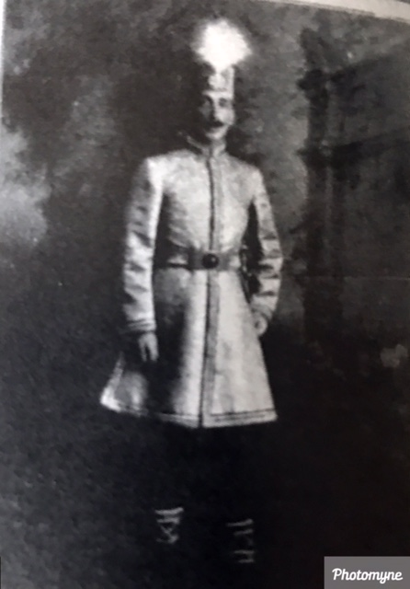
Figure 1: The Nawabzada Nusrat Ali Mirza of Murshidabad
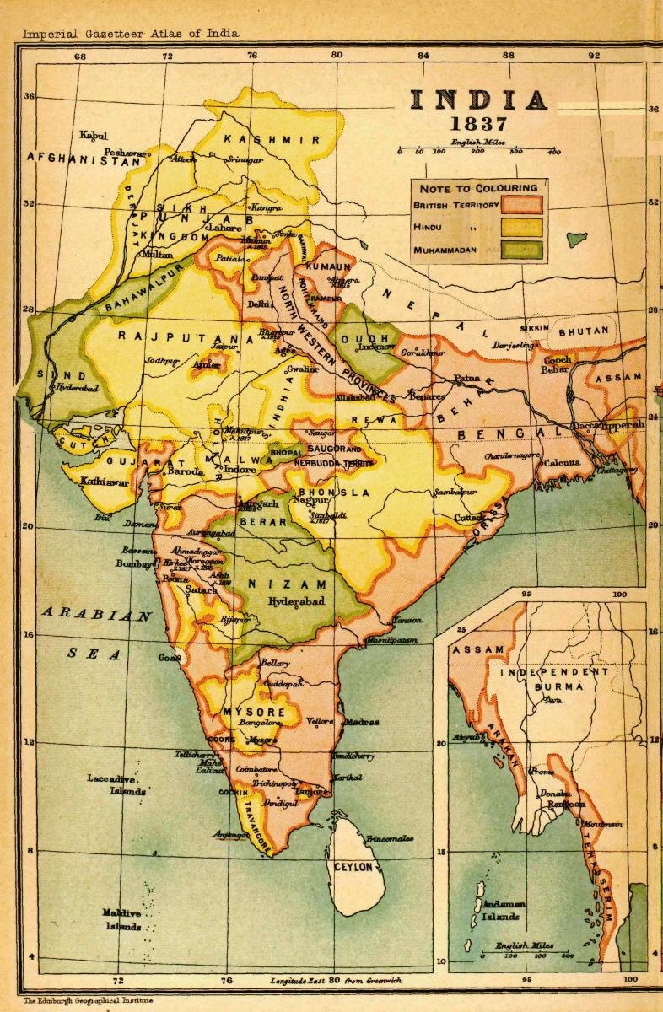
Figure 2: Map of India

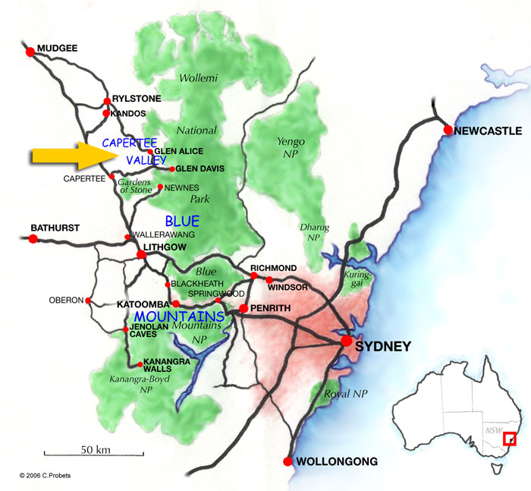

Figure 3: Capertee Valley, NSW, Australia.

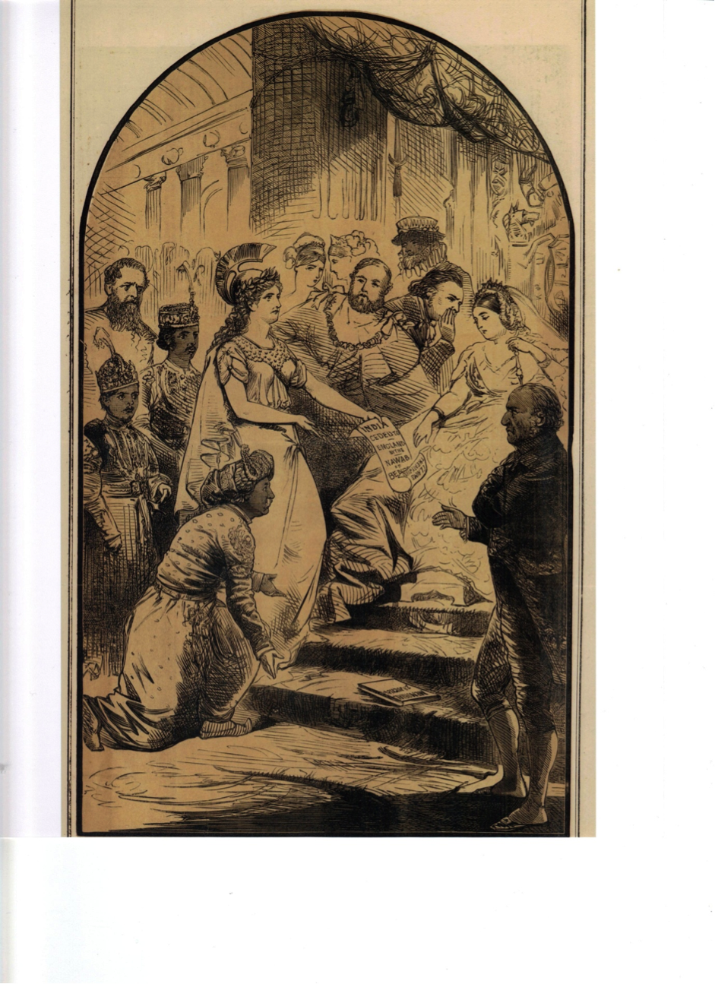
Figure 4. ‘Be Just and Fear Not’: cartoon by Matt Morgan in Tomahawk, April 16, 1870 showing the Nawab kneeling with Britannia petitioning Queen Victoria, his two sons standing behind him

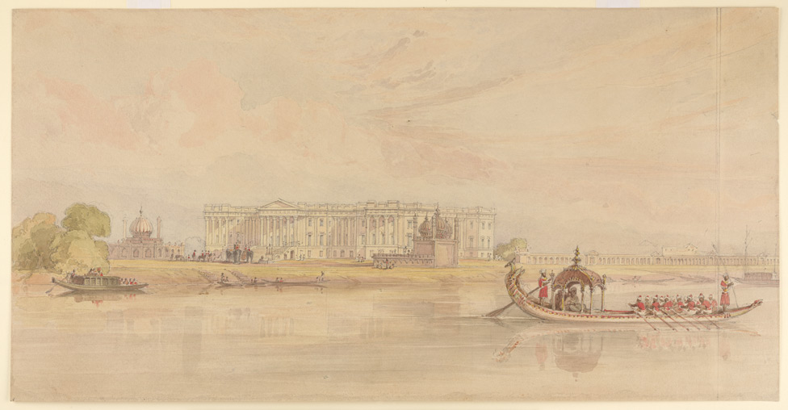
Figure 5: Hazarduari Palace (the Nizamut Kila), watercolour sketch c.1840 by William Princeps

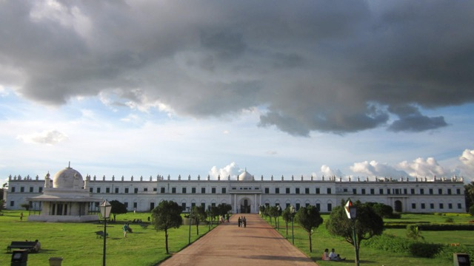

Image 5. The Imambara built by Mansour Ali Khan in 1846 opposite the Hazarduari Palace, Murshidabad. (Photo shared from Wikicom)
- 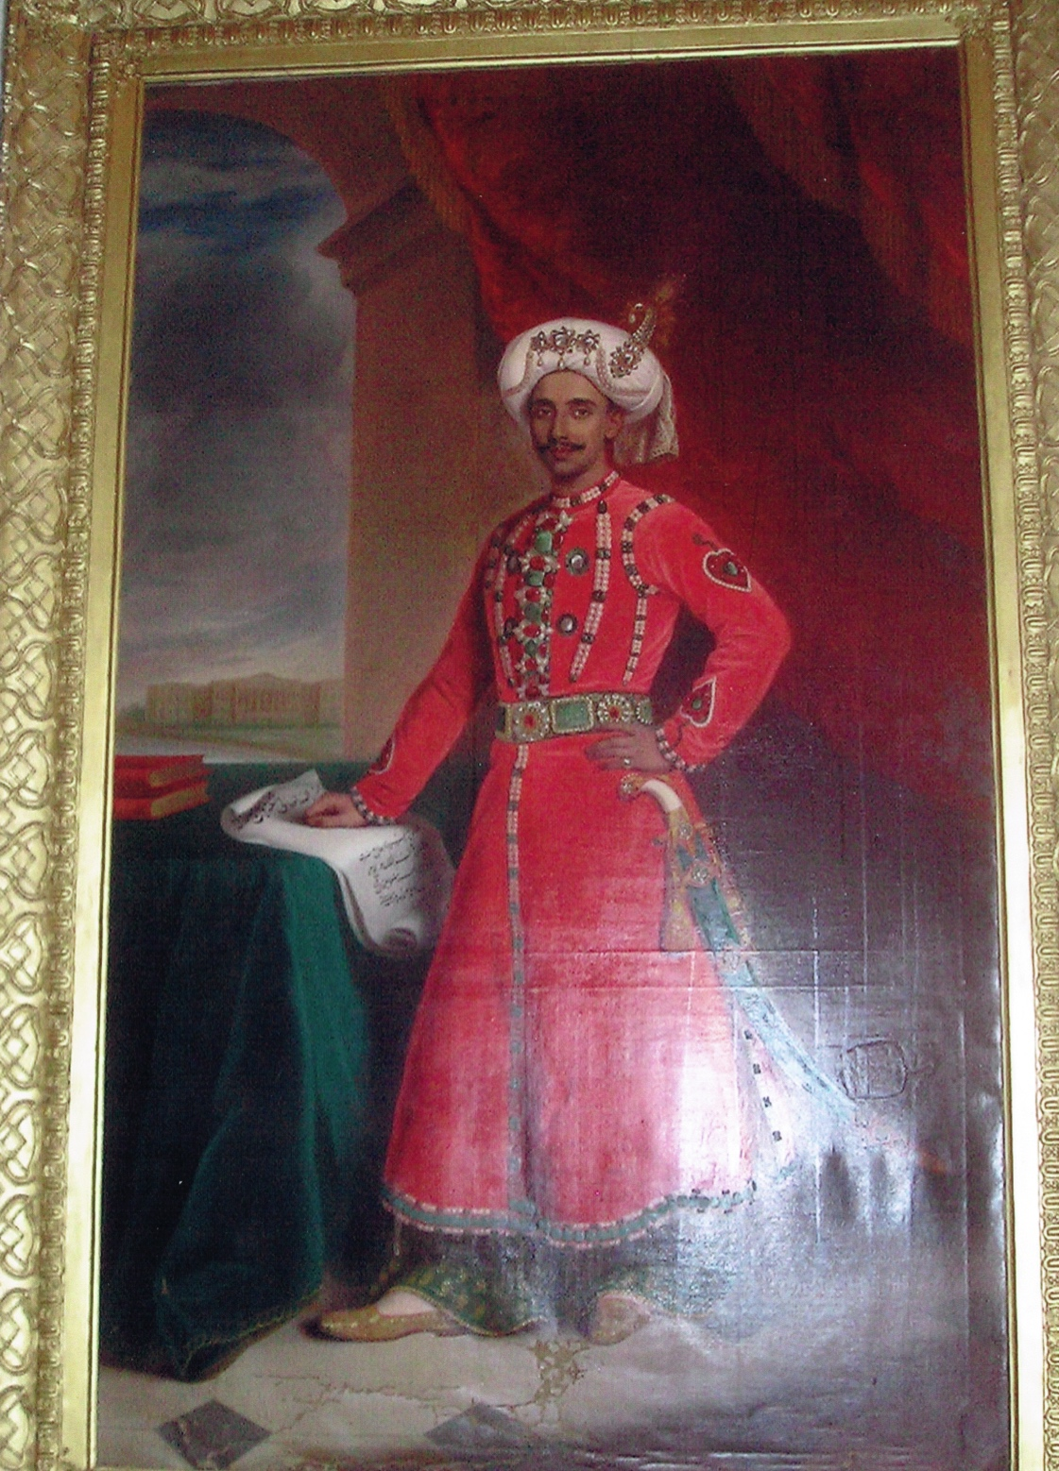

Figure 7. The Last Nawab of Bengal, Bihar and Orissa, aged 18

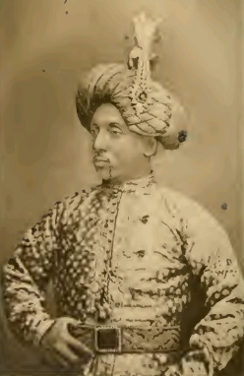

Figure 8:The Nawab, age c. 43, as he would have looked when he married Sarah Vennell

Helen MacKenzie, Storms and Sunshine of a Soldier's Life: Lt.-General Colin MacKenzie, C.B., 1825-1881, Vol. 2. (Edinburgh: David Douglas, 1884), pp.216-218.
They travelled on the SS Eldorado, leaving London November 16, 1880, arriving Calcutta, December 31, 1881. Homeward Mail from India, China, and the East, November 17, 1880.
Their father’s mother, Rais-un-nisa Begum. She died nine years after her son, in 1893.
Muharram occurs during the first month of the Islamic year, and is a commemoration particularly observed by Shia Muslims of the martyrdom of Husain, the Prophet Mahommed’s grandson, with 10 days of mourning, prayers, and processions,
The Bera festival (Bera Utsav) is usually held in September and is a celebration of the water deity. Murshidabad is particularly famous for its lavish celebration of this festival and spectacular firework display. It was during this festival in 1846 that the Imbarra caught fire, necessitating the building of the present one by the Nawab.

